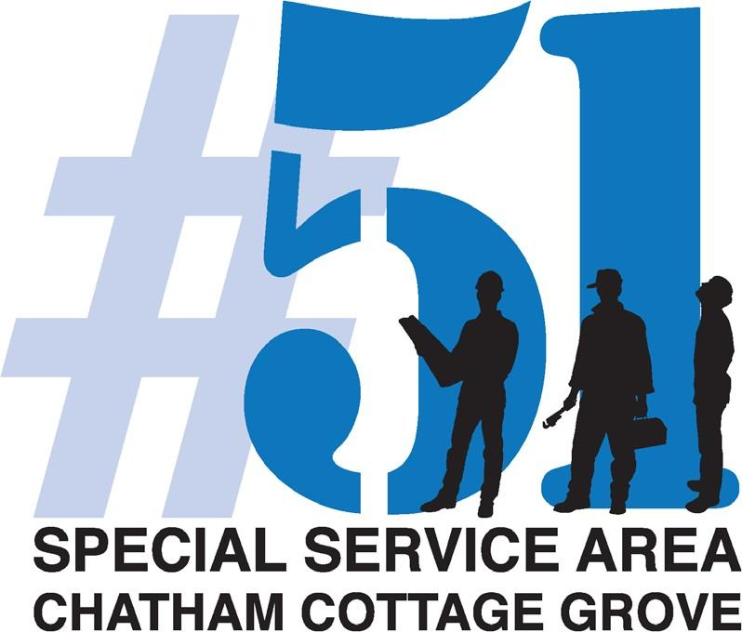

REPORT: Summary of Services

Prepared for Commissioners Open Meeting
August 16th, 2023
Prepared by
SSA #51 Service Provider
Chatham Business Association, Small Business Development Inc.

1.

SSA 2024 Budget: A budget meeting to go over the final 2024 budget will be held virtual on a date in the very near future.

2.

Advertising and Promotions
Important information, such as Business Certification, Financial Assistance and Technology Development are distributed regularly to the SSA #51 businesses. Communications are sent to SSA #51 Businesses of SSA #51 Services, Monthly Membership Meetings, SSA Quarterly Meetings and IT Ambassador Program.

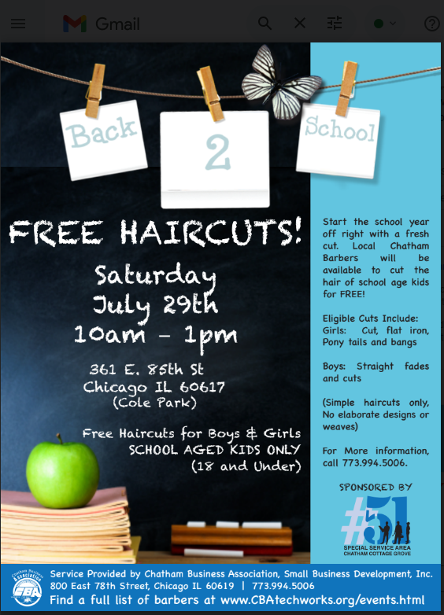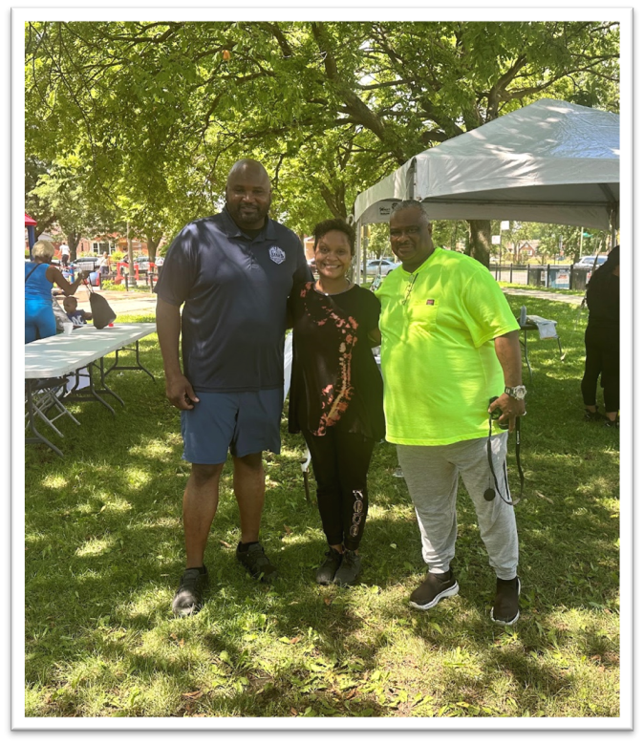
OVERVIEW
On Saturday, July 29th of 2023, Chatham Business Association (CBA) hosted one of two of its Annual Free Back to School Haircuts event. The July 29th event was hosted at Nat King Cole Park (361 East 86th Street) in conjunction with Elgie Sim’s Annual Back to School Festival. The events were hosted to bring the community and businesses together to prepare the youth for the start of the school year. The event also aided in promoting the barbers and salons to the neighboring communities. Special Service Area #51 – Chatham Cottage Grove hired salons and barbers to provide free haircuts to school aged children (18 and under) for four hours resulting in a total of 18 free haircuts and styles.

Total Number of Barbers: 2
Total Number of Salons: 3
Total Number of Free Haircuts/Hairstyles: 20
Barbers in Salons in Attendance included:
- Chicago Nine Social Club, 7854 E South Eberhart
2. Iman African Hair Braiding, 8230 S.Cottage Grove Ave
3. Nadia’s Beauty Salon, 215 E. 75th St
4. Style Lounge, 750 E. 75th St
5. Fabulous Fades, 9016 S Cottage Grove Ave
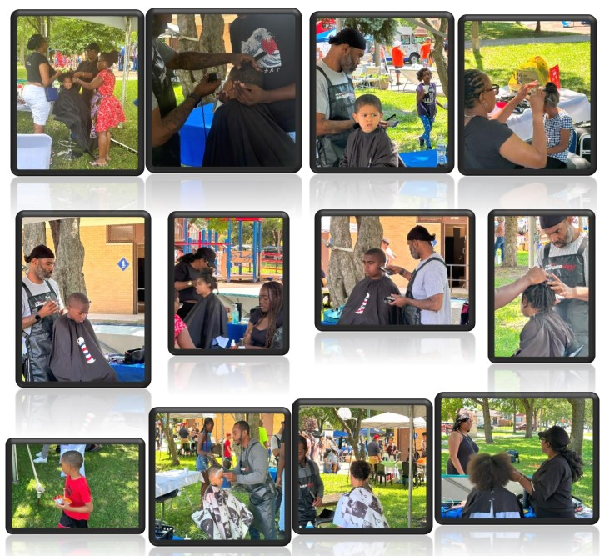
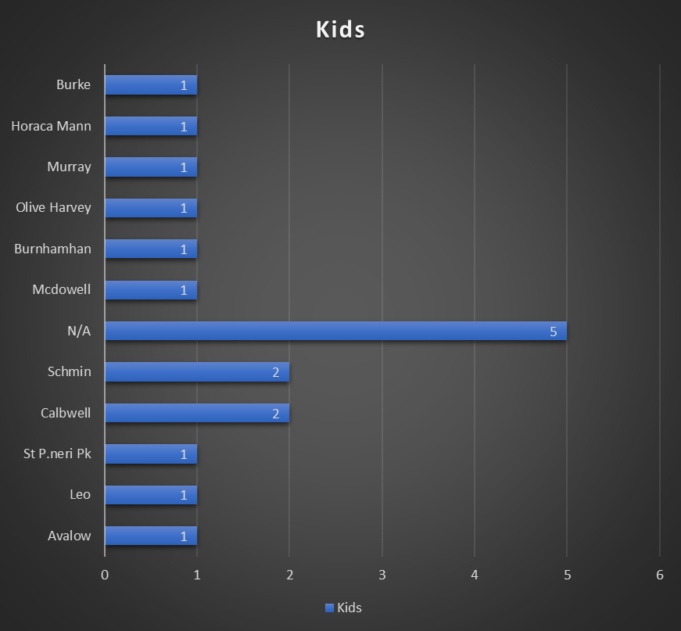
The chart above shows the schools the students came from who received their haircuts on Saturday July 29, 2023.
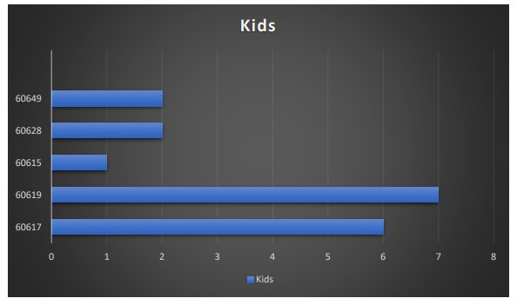
The students that participated in the Back-to-School Event came from different schools within the City of Chicago. The above chart shows the number of students from each school that attended the event on Saturday July 29, 2023.

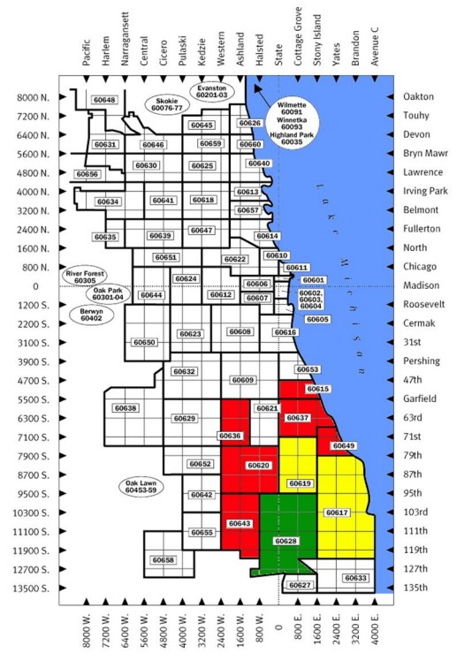
The clients for the Back to School Event came from 5 individual zip codes. The above map shows the number of clients that came from the different zip codes most students came from the 60619 and 60617 zip codes.
August Business of the Month 2023 - All About Kids, 502-516 East 75th Street

CBA, SBDI is also adamantly promoting the SSA businesses on their social media.
CBA will promote SSA #51 business deals and promotion on their Social Media sites

https://docs.google.com/presentation/d/1AUFS6CLu-SjIbCC0uIL7f91rtxzBQRuoAnARkAdjQ8E/edit?usp=drive_link
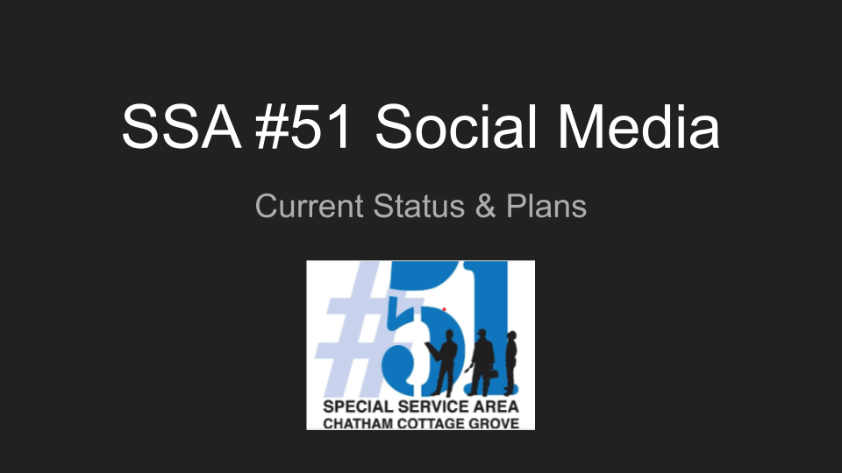

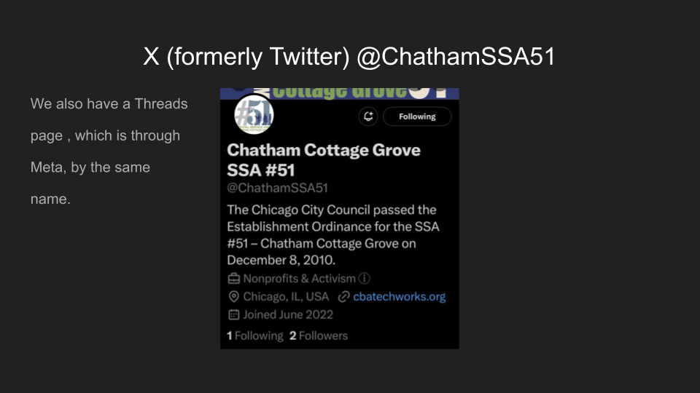
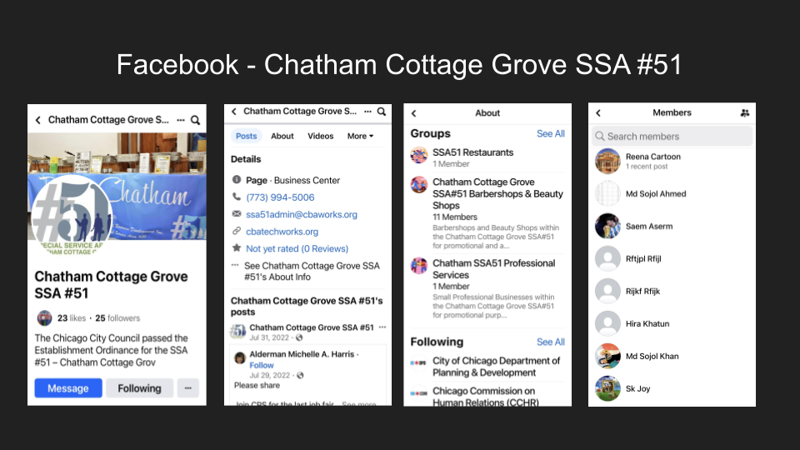
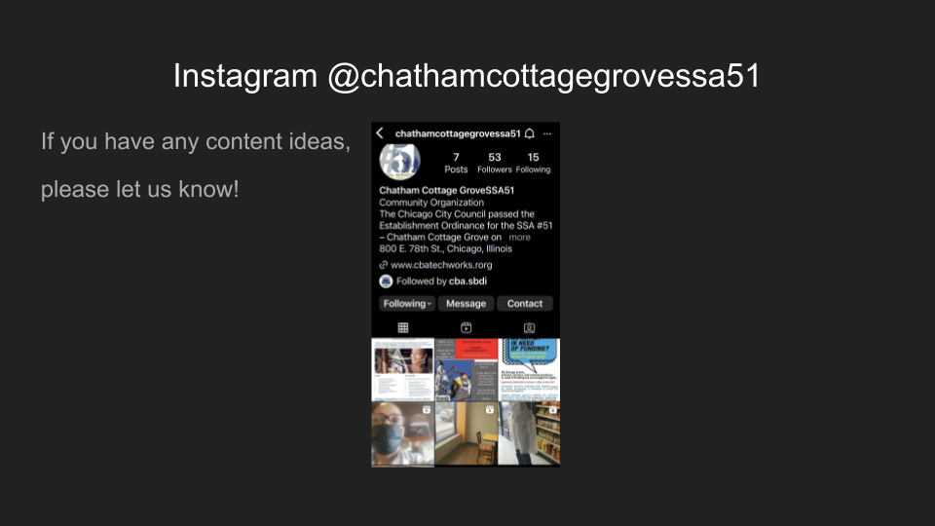
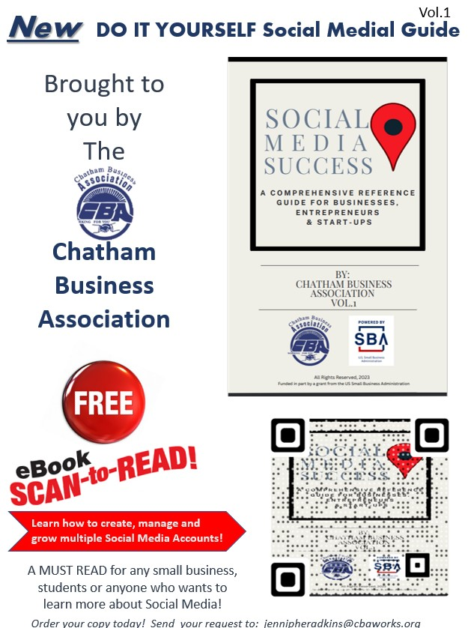

Chatham Business Association has created a Social Media Guide that will be shared with all businesses in our network.

3.

Public Way Maintenance
June 2023 - August 2023

Street Cleaning
Between June 6th and August 15th, a total of 906 bags (52 Gallon bags) of garbage were collected. In other words, 15,004 Gallons of garbage have been collected and removed from the streets of SSA #51 in the last three months. No changes in the street cleaning staff members during this quarter.

Areas within the SSA #51 that were cleaned include: 75th Street (Indiana to Drexel), 79th Street, 79th Street (Greenwood to Indiana), Cottage Grove (75th Street to 95th Street), and Vacant lots located on 75th Street, 79th Street, 95th Street and Cottage Grove Avenue. Reported by Cliff Borner, SSA 51 Field Program Manager

Public Works – CDOT
- Street resurfacing:
On 75th Street between Cottage Grove to 75th and Martin Luther King Drive.

Snow Removal:
The SSA #51 businesses will be surveyed in order to find out the timings they would prefer their snow to be removed. The survey options will include the following: 8:30 AM - Noon and Noon – 3:00 PM. There was no Snow removal reported this quarter.

4.

Public Way Aesthetics
SSA #51 Service Provider will promote the SSA# 51 businesses corridor with Banners, Custom Trash Containers and Planters. Five Custom Trash Receptacles permits were renewed along with 6 Planters within the Corridor.

SSA #51 Businesses were surveyed about planter and Street Pole planters were favored overall. Based on City guidelines, CBA will draw up a plan for the best placement for planters. Negotiate replacement of damaged SSA 51 banners with Temple Display in accord with SSA#51 budget. Damaged banners per Field Supervisor are included: 6 on 95th, 19 on Cottage Grove from 75th and 95th, 12 on 79th St Corridor, and 9 on 75th St Service Provider RFP’s for Banner Vendor to replaced damaged banners. Service provider will utiize the relationship with the Chicago Art Institute to assist with the installation of the banners.

5.

Holiday Decorations
Service Provider Bannerville began negotiating Holiday décor, and input is requested on the following options:

Run Time: (November 1– January 1)

Wreaths on poles (placement would be on every 2nd pole).
We have the wreaths and some bows, we would need to purchase pole attachments.
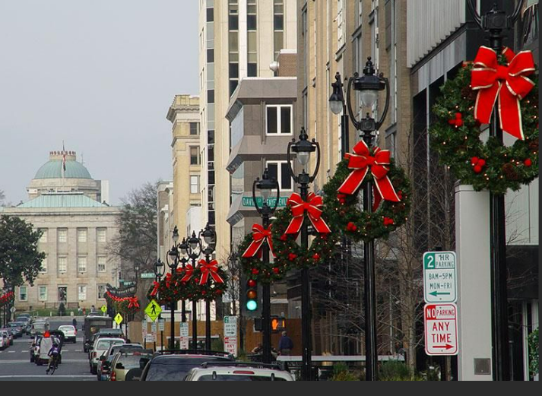

6.

Façade Improvements
No New projects this quarter, but there is interest from Sizzlin Skillets.

7.

Safety Programs
A cybersecurity program is underway.

8.
Reports
Database Demo of Information being Collected within SSA #51
https://docs.google.com/presentation/d/19a0s4D_GWEuXit6JRgcKt76y97Qxy9u7j43EmaDgoiQ/edit?usp=drive_link
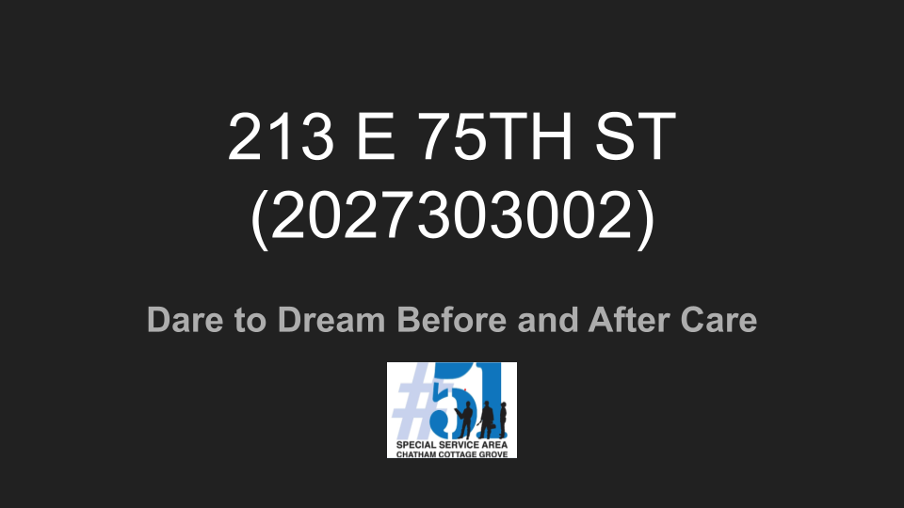
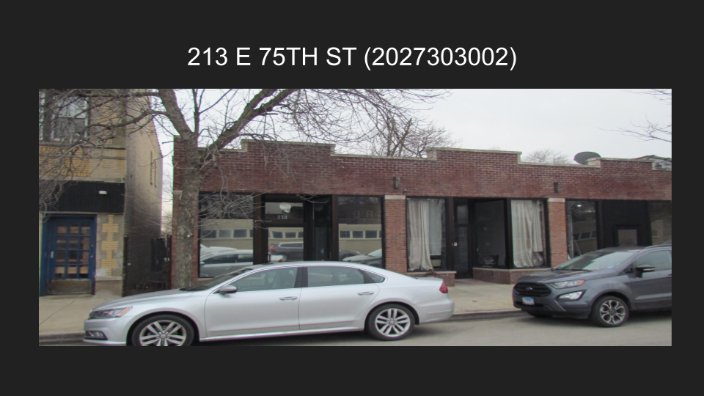
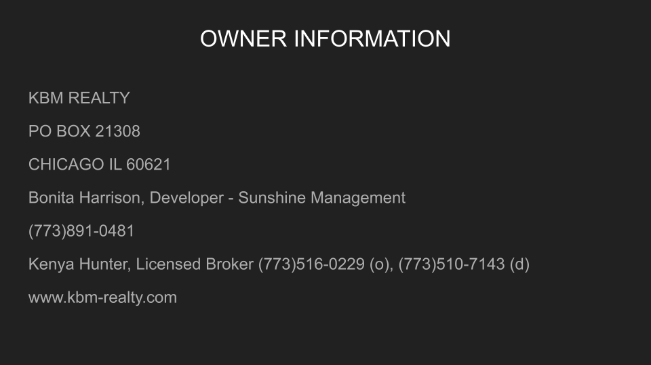
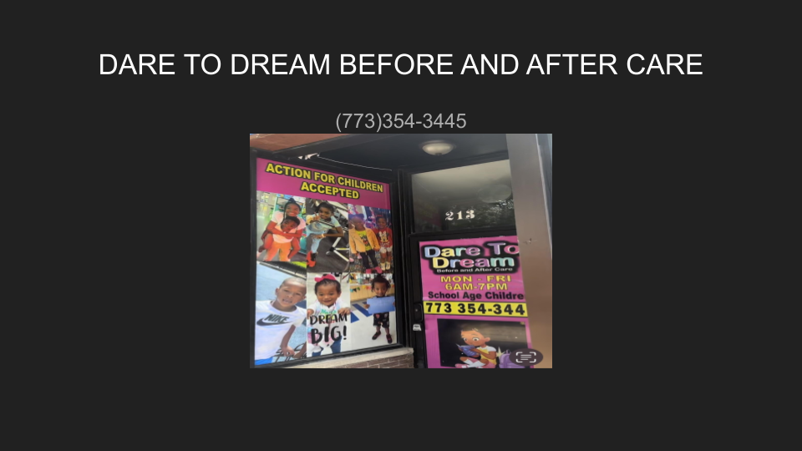
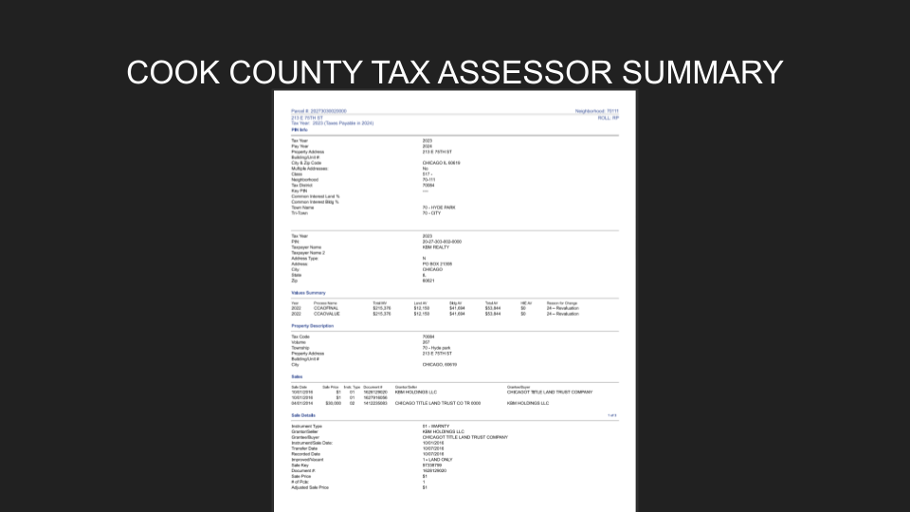
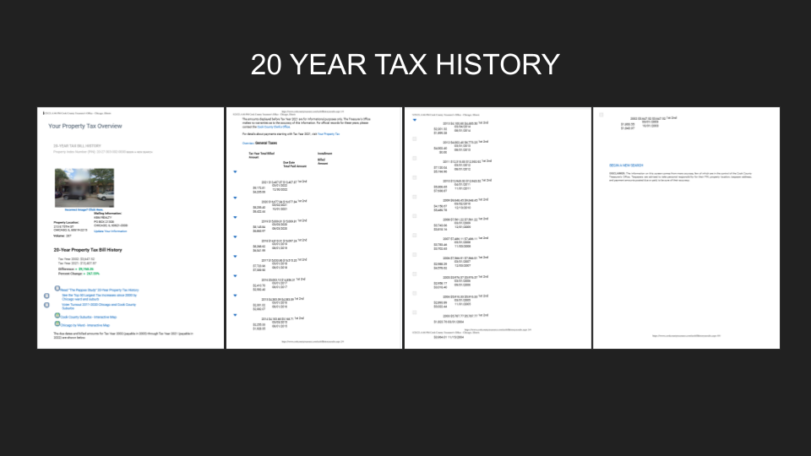

Input was taken and the final database will exclude the 20 Year Tax History and be in a spreadsheet format with minimal links to external sites for data.

9.
New Ideas and Business
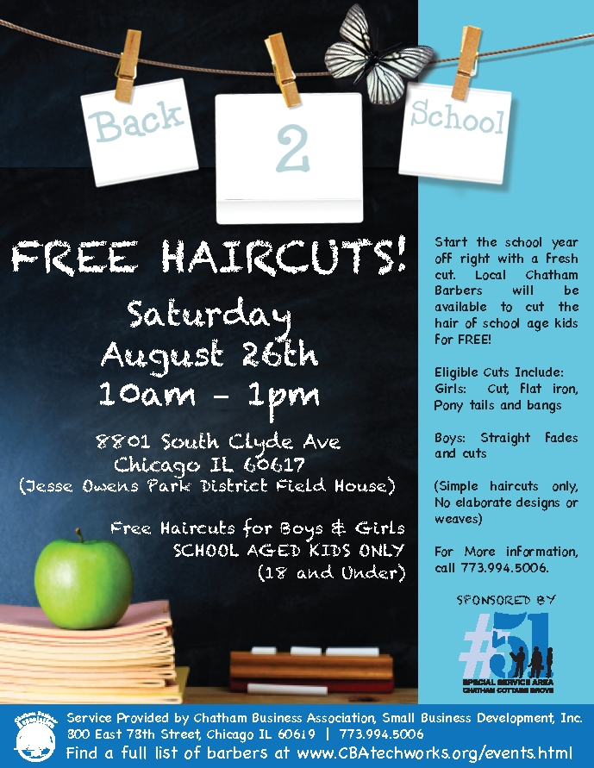

Alderperson Michelle Harris hosts an annual Back to School event, being held on Saturday August 26, 2023 at Jesse Owens Park. SSA #51 will provide hair services to children attending this event.

IDA Chatham Tour
2023 Annual Conference - International Downtown Association
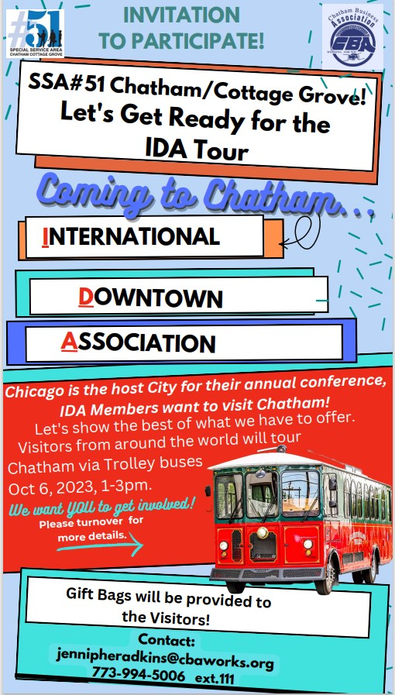
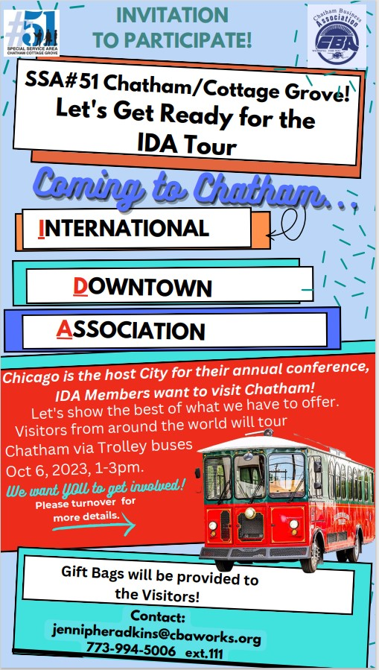

The International Downtown Association Annual Conference will be held Oct 6, 2023and will include a tour of Chatham. We will be including our SSA #51 businesses in this event.

Chicago Art Institute -FREE TICKETS THROUGH 12/31/2023
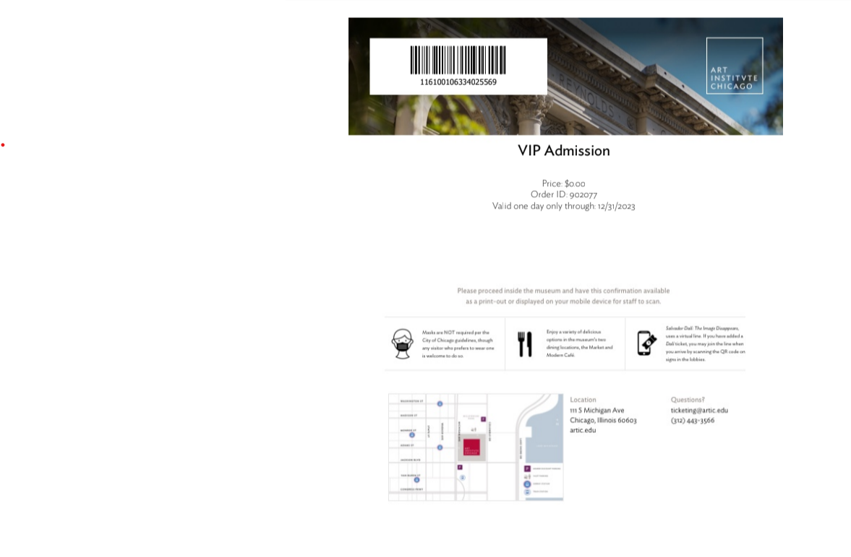
We are offering our members free tickets to Chicago Art Institute through the end of the year.

